**Basic syntax in groovy**

**The following are the conditions applied while writing the groovy program:**

* In groovy, it is not necessary to put a semicolon at the end of the statement like in java.

**Example:**

1. **package** com.app
2. **class** Demo {
3. **static** **void** main(args) {
4. print ("Welcome to Javatpoint tutorial on Groovy... ")
5. }
6. }

**Output:**

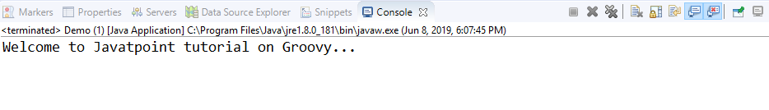

* In groovy, we can print a line without using round brackets

**Example:**

1. **package** com.app
2. **class** Demo {
3. **static** **void** main(args) {
4. print "Welcome to Javatpoint tutorial on Groovy... "
5. }
6. }

**Output:**

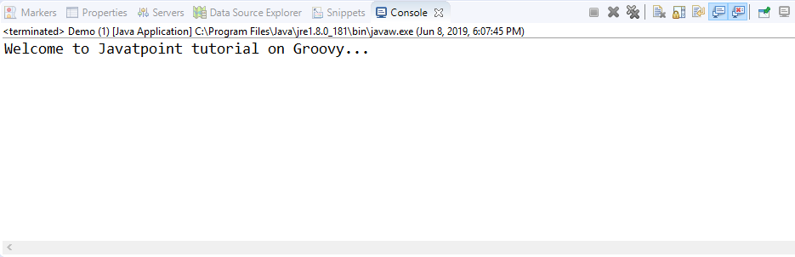

* In groovy, double quotes as well as single quotes can be used in a string.

**Example:**

1. **package** com.app
2. **class** Demo {
3. **static** **void** main(args) {
4. print 'Welcome to Javatpoint tutorial on Groovy...'
5. }
6. }

**Output:**

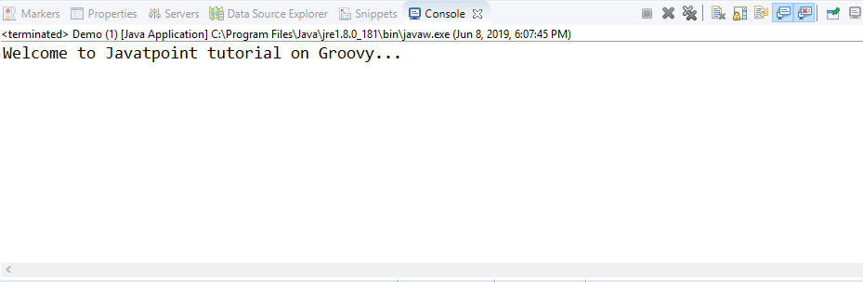

* We can have a single line comment as well as a multi-line comment just like in java.

**Example:**

1. **package** com.app
2. **class** Demo {
3. // this is a single line comment
4. /*
5. *
6. * this is a
7. * multi-line comment
8. */
9. **static** **void** main(args) {
10. print "Welcome to Javatpoint tutorial on Groovy... "
11. }
12. }

**Output:**

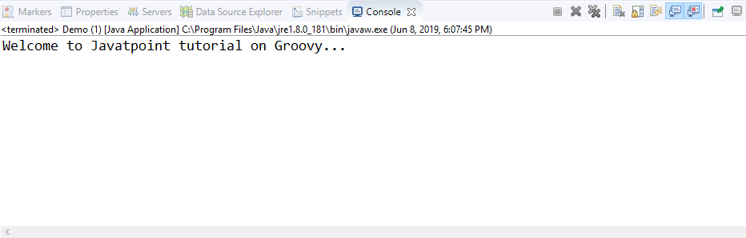

* In Groovy, it is not necessary to have a class or the main function.

**Example:**

1. **package** com.app
2. print "Welcome to Javatpoint tutorial on Groovy... "

**Output:**

